MSUCOM Medical Equipment List – Incoming Students
Class of 2030 | Last Updated: 5/1/2026
Overview
MSUCOM students are required to have specific medical equipment for laboratory and clinical skills training. Most required items must be available by Day 1 of class and will be used throughout your medical education.
Why It Matters
Hands-on practice with your own equipment helps build confidence, consistency, and clinical competency. These skills are taught and assessed throughout the curriculum and are essential for patient care.
What You Need to Do
- Obtain required equipment:
Most items must be purchased by the student. Borrowing from family or friends is allowed, but owning your own equipment is strongly recommended.
- Bring equipment to every applicable lab: Steeles MSUCOM Student Package
Regular use of your own instruments is important for skill development and assessment.
Ordering Options
MSUCOM partners with Steeles Medical Supply to offer a student discount.
- Visit: Steeles MSUCOM Student Package
- Use coupon code: MSUCOM for a 6% discount, valid at any time during enrollment and usable on any eligible Steeles items (not limited to the linked package).
The linked MSUCOM student package highlights items that meet minimum MSUCOM requirements or are faculty recommended/preferred. Students may purchase equipment from any vendor, provided items meet MSUCOM standards outlined in this document.
Important Notes
- This list was developed by MSUCOM faculty in collaboration with Steeles Medical Supply, a Michigan-based partner supporting MSUCOM for over 30 years.
- Avoid borrowing equipment from current students, who will need their supplies at the same time.
- All required items must be ready by Day 1 of class (July 13, 2026).
- Semester 1 financial aid budgets include funds intended for medical supplies; students are encouraged to plan accordingly.
- A webinar on May 5, 2026, will review required equipment and purchasing options.
- Orders that include engraving or embroidery should be placed by June 1, 2026, to ensure delivery before Day 1.
How to Read This List
- Items labeled Required must be obtained by Day 1.
- Items labeled Required (Provided) are required but will be supplied by MSUCOM; no purchase is necessary.
- Items labeled Optional / Faculty Preferred are not required but are recommended by faculty.
- When more than one option is listed for a required item, all options meet MSUCOM requirements.
  - The ★ Faculty Choice is provided only to help students decide between acceptable options.
- Detailed descriptions appear below the summary tables to help students identify equivalent items when purchasing from other vendors.
Understanding Product Descriptions and MSUCOM Guidance
Each item may include two types of information:
- Product descriptions provide manufacturer or vendor details to help identify acceptable specifications and comparable items.
- MSUCOM guidance (shown in italics) reflects faculty or program input explaining why an item is needed, how it is used, or important considerations such as timing or acceptability.
Tip for students: Focus on MSUCOM guidance to understand expectations; use product descriptions to compare equivalent options across vendors.

Required & Optional Equipment – Quick Reference
(This table helps you decide what you need.)
Medical Supply Item | Link to Details Below
Stethoscope (Provided by MSUCOM) | [View Details]
Diagnostic Set (Choose One) | [View Details]
Blood Pressure Kit (Choose One) | [View Details]
Small / Neuro Instruments (Required – One Each)
Tuning Fork | [View Details]
Reflex Hammer | [View Details]
Measuring Tape | [View Details]
Pocket Eye Chart | [View Details]
Pen Light with Pupil Gauge | [View Details]
Digital Thermometer | [View Details]
Digital Thermometer Covers | [View Details]
Diagnostic Set Accessories | [View Details]
Monofilament Foot Screen Test | [View Details]
Eye Protection | [View Details]
Nitrile Gloves | [View Details]
Scrub Top | [View Details]
Scrub Bottom | [View Details]
Other Optional Items – (All Are Faculty-Recommended)
Equipment Bag | [View Details]
EKG Caliper | [View Details]
Cotton Tip Applicators | [View Details]
Tongue Depressors | [View Details]
Alcohol Swabs | [View Details]
Analog Timing Device | [View Details]
Suture Kit | [View Details]
Hospital Gown | [View Details]

View Details – Expand sections to see all details. Links above will not open content that is collapsed.

Equipment Details & Guidance
(Expanded descriptions to help compare equivalent items across vendors.)
Item | Example Image | Steeles Product Information w/ MSUCOM Guidance
Stethoscope | 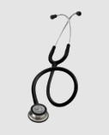 | N/A – Littmann Classic III – Provided by MSUCOM [back]  MSUCOM guidance:  Students do not need to purchase a stethoscope. Each student will receive a Littmann Classic III on the first day of in-person orientation as part of a shared professional commitment ceremony. This stethoscope is provided through the Michigan Osteopathic College Foundation (MOCF) with support from MSUCOM faculty, staff, and alumni contributions. Students who prefer a different model may choose to purchase and use their own.
Diagnostic Set | 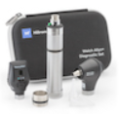 | 71-SM2CXX Coax/Macro/Nicad Diagnostic Set [back]  ★ Faculty Choice  Set Components  - 11720-L Coaxial Ophthalmoscope  - 238-2 Macroview Basic Otoscope  - 71000-C 3.5v Nicad Power Handle  - Hard Case  MSUCOM guidance:  This diagnostic set meets MSUCOM requirements and is faculty-preferred when students are choosing between acceptable options. The Nicad and Lithium diagnostic sets are both acceptable. Differences relate to the power handle only: Nicad is heavier, holds a charge for approximately one hour, and can convert to C batteries; Lithium is lighter, holds a charge for approximately two hours, and has no memory effect when charging. The Lithium option is more expensive. Selection is based on student personal preference.
Diagnostic Set | 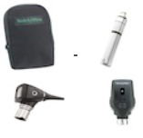 | 71-SS2CXX Coax/Basic/Nicad Diagnostic Set [back]  Set Components  - 250-2 Diagnostic Otoscope  - 11720-L Coaxial Ophthalmoscope  - 71000-C Nicad Convertible Power Handle  - Hard Case  This set meets MSUCOM requirements and is an acceptable option. It is smaller and more compact than the MacroView set. Selection between acceptable diagnostic sets is a matter of student personal preference.
Diagnostic Set | No image available. | Power Handle Laser Engraving [back] (Optional Upgrade)  Available on above diagnostic set power handles (Steeles only). 10-character limit. Engraved items are NOT returnable.  MSUCOM guidance:  Engraving is optional and available only through Steeles. Engraved items are not returnable. This option does not affect equipment requirements and is based on student personal preference.
Blood Pressure Kit | 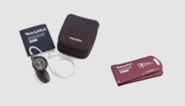 | DS58 Classic Hand Aneroid w/Adult & Child Cuff [back]  - kit includes large adult cuff, adult cuff, child cuff, and case  - thumbscrew gauge with lifetime calibration warranty  - Order DS58-ST with Reuse-12 to obtain all necessary cuffs.  - Large Adult (maroon), Adult (navy), and Child cuffs are needed; all other aspects are personal preference to the student.  MSUCOM guidance:  This kit includes only the cuff sizes required by MSUCOM. Additional features beyond required cuff sizes are a matter of student personal preference.
Blood Pressure Kit | 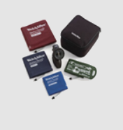 | DS58-MC Classic Hand Aneroid Family Practice Kit [back] ★ Faculty Choice  - kit includes large adult, adult, small adult, and child cuffs  - thumbscrew gauge with lifetime calibration warranty  Maintain accurate blood pressure readings with lower lifetime cost.  Incorporating our gear-free, shock-resistant DuraShock Technology, the Welch Allyn Tycos DS58 Classic is one of three premium models in the new Welch Allyn platinum series product range. With an ergonomic design for optimal comfort and a lifetime calibration warranty, you can count on the DS 58 to hold up to the way you work--and give you lower cost over time.  Features  - Jeweled movement for long life  - Laser-engraved dial for accuracy  - Premium inflation system for comfort  - Super shock-resistant--can withstand up to 60" drop and remain accurate  - Lifetime calibration warranty  - Premium aesthetics  - Ergonomic inflation bulb  - Lifetime calibration warranty  Key Components  - DS58 Hand Aneroid  - Adult One-tube Durable One-piece Blood Pressure Cuff  - Large Adult One-tube Durable One-piece Blood Pressure Cuff  - Small Adult One-tube Durable One-piece Blood Pressure Cuff  - Child One-tube Durable One-piece Blood Pressure Cuff  - Case  - Tri-Purpose Connector  MSUCOM guidance:  This kit includes one additional cuff size (small adult) beyond MSUCOM requirements. Both this kit and the basic DS58 kit meet requirements; the faculty-preferred option is provided to help students decide between acceptable options. Selection is based on student personal preference.
Small / Neuro Instruments (Required – One Each)
Tuning Fork | 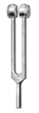 | 1314 C-128 Tuning Fork [back]  Low frequency medical tuning fork for neurological testing.  MSUCOM guidance:  This tuning fork by itself meets MSUCOM requirements. Additional tuning forks, if purchased, are optional and based on student personal preference.
Reflex Hammer | 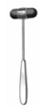 | 1312 Dejerine Hammer [back]  MSUCOM guidance:  Used for neurological assessment. Other reflex hammer options are acceptable and selection is based on student personal preference. This model is preferred by MSUCOM Neuro faculty.
Measuring Tape | 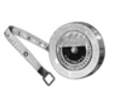 | 1340 Tape Measure [back]  - Graduated in inches and centimeters  - High-impact plastic case with push-button retractor mechanism  - Tape made of fiberglass  - Size: 1/4” wide by 60”  MSUCOM guidance:  Must be flexible to allow measurement around body parts. Other tape measures that meet this requirement are acceptable.
Pocket Eye Chart | 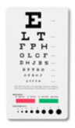 | 1243 Pocket Eye Chart Snellen [back]  Snellen Pocket Eye Chart. Ruler/Visual Acuity Card with Pupil Gauge. 6 foot distance. 7 1/4" x 3 7/8" Plastic Card  MSUCOM guidance:  This item meets MSUCOM requirements. Other pocket eye charts with equivalent functionality are acceptable.
Pen Light with Pupil Gauge | 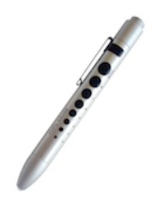 | 214-SIL Soft LED Pupil Gauge Penlight Silver [back]  This penlight is push button activated and features metal construction, soft LED illumination and includes 1-AAA battery. Features a pupil gauge imprint on the side.  MSUCOM guidance:  Used for pupil examination. Other penlights with pupil gauge functionality are acceptable and selection is based on student personal preference.
Digital Thermometer | 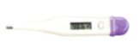 | 1530 Digital Thermometer [back]  Fast. Accurate. Safe  - Clinical accuracy  - Beeps at peak temperature  - Memory recall  Features:  - Fast - 60 second temperature readout  - Clinical accuracy to 2/10th of a degree  - Tone signal indicates peak temperature  - Memory recall of last reading  - Large, easy-to-read digital display  - 5 probe covers  - Convenient storage case  - Automatic shut off  - Long life battery  - Limited one-year warranty  - Detailed English & Spanish Instructions  MSUCOM guidance:  This thermometer meets MSUCOM requirements. Other digital thermometers are acceptable and selection is based on student personal preference.
Digital Thermometer Covers | 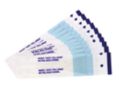 | 3600 Thermometer Covers 50 [back]  Digital Thermometer Covers Bag of 50  MSUCOM guidance:  Students must obtain thermometer covers compatible with their selected digital thermometer.
Diagnostic Set Accessories | 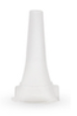 | 52434-34 Adult Specula 34 [back]  - Disposable specula eliminate cross-contamination  - Clear specula for enhanced illumination  - 34 specula. Compatible with the 23810/23820 MacroView Otoscope and 25020 Diagnostic Otoscope.  MSUCOM guidance:  Specula must be compatible with the student’s selected diagnostic otoscope. Students should ensure compatibility based on their otoscope choice.
Monofilament Foot Screen Test | 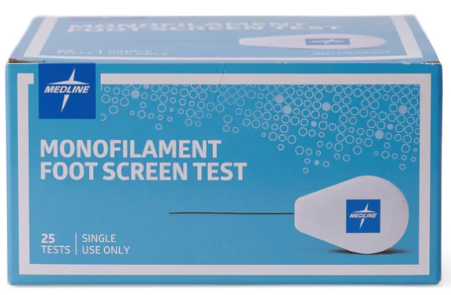 | MSC0002 Monofilament Foot Screen Test [back]  1 pack  MSUCOM guidance:  Standard screening tool used to assess patients at risk for diabetic foot complications.
Eye Protection | 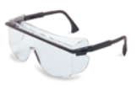 | 3001 Uvex Astrospec Eyewear Black [back]  Protective Eyewear  - Anti-scratch polycarbonate lens  - Anti-fog, Anti-static design  - Meets ANSI Z87.1 standards  - Features UV 400 Protection  MSUCOM guidance:  Eye protection must meet ANSI Z87.1 standards. Other eyewear meeting this standard is acceptable.
Nitrile Gloves | 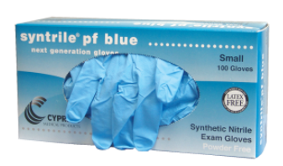 | 2790 Nitrile Latex Free Powder Free Gloves [back]  MSUCOM guidance:  Latex gloves are not permitted. Nitrile or other approved non-latex gloves must be used.
Scrub Top | 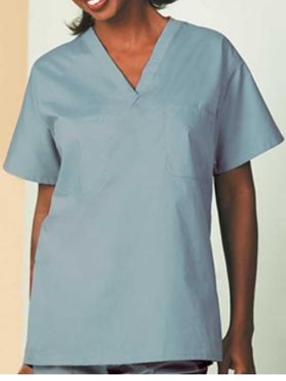 | S96 Scrub Shirt Misty Blue (with or without logo) [back]  MSUCOM guidance:  One set of scrubs (shirt and pants) is required for anatomy lab during the first semester. Students may choose any color; embroidery and logo options are personal preference.
Scrub Bottom | 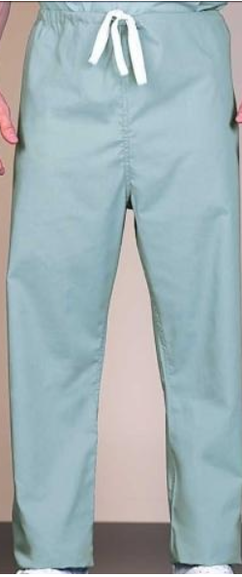 | SB96 Scrub Pants Misty Blue [back]  MSUCOM guidance:  One set of scrubs (shirt and pants) is required for anatomy lab during the first semester. Students may choose any color; embroidery and logo options are personal preference.
Other Optional Items – (All Are Faculty-Recommended)
Equipment Bag | 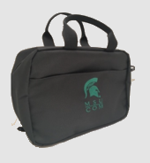 | C85215 Nylon MedBag Black [back]  Select Medical Bag with free MSUCOM logo  The C85215 Multipocket Medbag is our most popular bag. It can adequately fit all of your required instruments and is appropriately sized for transporting your equipment.  This quality bag is constructed of durable nylon inside and out. It features a foam padded liner for added protection of your equipment, 10 interior pouches, an interior zipper pocket, 2 spacious outer pockets, web handles and adjustable shoulder strap.  MSUCOM guidance:  A medical bag is recommended to store and transport required equipment. Other bags of appropriate size and durability are acceptable. Selection is based on student personal preference.
Equipment Bag | 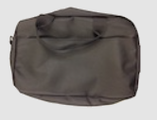 | E85215 Economy Medbag Black [back]  MSUCOM guidance:  A medical bag is recommended to store and transport required equipment. Selection is based on student personal preference. Approx. 12x12x 6
EKG Caliper | 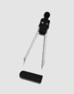 | 1343 EKG Caliper [back]  MSUCOM guidance:  Not used until Semester 5. Used for electrocardiogram interpretation. Other models are acceptable.
Cotton Tip Applicators | 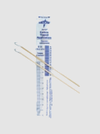 | 0010 Cotton Tip Applicators 10 [back]  MSUCOM guidance:  Common clinical supplies. Equivalent products are acceptable.
Tongue Depressors | 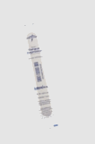 | 0011 Disposable Wooden Tongue Depressors 10 [back]  MSUCOM guidance:  Common clinical supplies. Equivalent products are acceptable.
Alcohol Swabs | 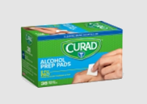 | 0013 Alcohol Swabs 10 [back]  MSUCOM guidance:  Common clinical supplies. Equivalent products are acceptable.
Analog Timing Device | 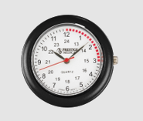 | Stethoscope Watch [back]  MSUCOM guidance:  This item is optional. Students must have access to a non-internet-enabled timing device for assessments; a stethoscope watch is one acceptable option. Selection is based on student personal preference.
Suture Kit | 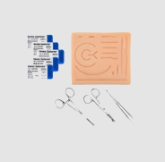 | 9101 Suture Kit [back]  9101 Economy Suture Kit with the following instruments:  - (1) Crilewood Needle Holder 6"  - (1) Iris Scissor Straight 4.5"  - (1) Adson Tissue Forcep 4 3/4 1 x 2  - (1) Vinyl Case  Stainless steel instruments NOT recommended for autoclaving.  MSUCOM guidance:  Not used until Semester 6. Students may select any suture kit that includes the required components listed. Selection is based on student personal preference.  - Needle driver  - Forceps/pickups without teeth (Adson forceps preferred)  - Suture scissors  - Suture  - Suturing board/suturing pad.
Hospital Gown | 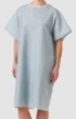 | 1120 Patient Gown Unisex One Size Tie Back [back]  Patient Gown Unisex One Size Tie Back  MSUCOM guidance:  Optional item for personal use during exams and class for comfort and modesty. Selection is based on student personal preference.

