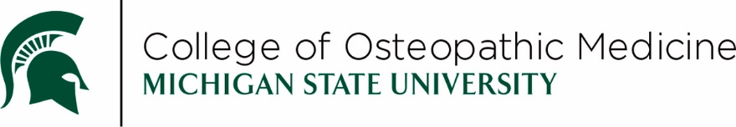

Semester 1 Overview
  - Class of 2030 - Summer Semester 2026 (US26)
This document serves as a guide for many of the notable events scheduled in Semester 1 and may be subject to change. Students are responsible for reviewing the course schedule for the finalized dates, times, and locations of all course events as well as reviewing the schedule/syllabus to understand the course requirements. *While efforts are made, it is not always feasible to avoid all religious observances when developing the schedule; students may request excused absences when an exam conflicts with a religious observance.
Date | Time | Event
Monday, June 22, 2026 | N/A | Semester 1 Begins
Tuesday, July 8, 2026 | 9:30am | Class of 2030 Orientation – Kellogg Center
Wednesday, July 9, 2026 | 8:00am | Site Orientation
Thursday, July 10, 2026 | 8:00am | Continued Orientation
Monday, July 13, 2026 | Various times | Examplify Orientation and Practice Exam
Thursday, July 16, 2026 | 8:00am | FACts Quiz
Monday, July 20, 2026 | 8:00am | RECR hours 1 & 2
Friday, July 24, 2026 | 9:00am | RECR hour 3
Thursday, July 23, 2026 | Various times | OST510 MOCK Practical Exam
Wednesday, July 29, 2026 | 9:00am | S1UE1 – OST510 Written Exam 1
Wednesday, July 29, 2026 | Various times | S1UE1 – OST510 Lab Exam 1
Tuesday, August 4 – Thursday August 6, 2026 | Various times | Basic Life Support Sessions
Wednesday, August 12, 2026 | 9:00am | S1UE2 – OST510 Written Exam 2
Wednesday, August 12, 2026 | Various times | S1UE2 – OST510 Lab Exam 2
Thursday, August 13, 2026 | 8:00am | OST550 Mandatory, Live sessions
Friday, August 14, 2026 | 11:00am  (doors open) | MSUCOM White Coat Ceremony – Breslin Center
Friday, August 14, 2026 | N/A | Semester 1 Ends
Monday, August 24, 2026 | N/A | Semester 2 Begins

Remediation opportunities for Semester 1 will take place during the week of August 17, 2026.
In addition to the events above, Semester 1 will have mandatory, live events on almost all days, Monday-Friday throughout the semester.

