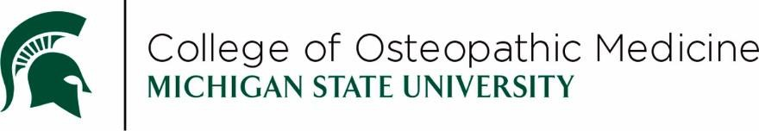

Semester 5 Overview

Class of 2029 - Fall Semester 2026 (FS26)
This document serves as a guide for many of the notable events scheduled in Semester 5 and may be subject to change. Students are responsible for reviewing the course schedule for the finalized dates, times, and locations of all course events as well as reviewing the schedule/syllabus to understand the course requirements.
While efforts are made, it is not always feasible to avoid all religious observances when developing the schedule; students may request excused absences when an exam conflicts with a religious observance.
Date | Time | Event
Monday, August 24, 2026 | N/A | Semester 5 Begins
Monday, August 24, 2026 | 1:00pm | Class of 2029 Semester 5 Orientation
Friday, September 4, 2026 | 9:00am | S5UE1 – OST534
Monday, September 7, 2026 | N/A | MSU Closed for Labor Day Holiday
Monday, September 21, 2026 | 9:00am | S5UE2 – OST534
Friday, September 25, 2026 | Various times | Base Hospital Expo
Monday, October 5, 2026 | 9:00am | S5UE3 – OST534
Thursday, October 15, 2026 | 9:00am | S5UE4 – OST534
Friday, October 16, 2026 | N/A | Mid-Semester Break
Thursday, October 22, 2026 | Various times | OMM514 Practical Exam #1
Wednesday, October 28, 2026 | 9:00am | S5UE5 – OST535
Thursday, November 5, 2026 | 9:00am | S5UE6 – OST535
Friday, November 6, 2026 | 8:00am | IPE Seminar
Monday, November 16, 2026 | 9:00am | S5UE7 – OST535
Monday, November 16 – Friday, November 20, 2026 | Various times | OST554 OSCEs & OST535 Live events
Thursday, November 19, 2026 | Various times | OMM514 Practical Exam #2
Monday, November 23, 2026 | Various times | Mandatory live events for all sites
Thursday, November 26 –  Friday, November 27, 2026 | N/A | MSU Closed for Thanksgiving Holiday
Thursday, December 3, 2026 | 9:00am | S5UE8 – OMM514 written final
Tuesday, December 8, 2026 | Various times | S5UE9 – OST535 Lab exam
Wednesday, December 9, 2026 | 9:00am | S5UE10 – OST535
Friday, December 11, 2026 | N/A | Semester 5 Ends  FCM preceptorships may be scheduled between S5 and S6.
Monday, January 4, 2027 | N/A | Semester 6 Begins
Remediation exams for Semester 5 will take place the week of December 14th, 2026.

Additional mandatory live sessions, not including OMM & OPC labs, occur on the following dates: 8/25/26, 9/1/26, 9/2/26, 10/7/26 (EL), 10/12/26 (DMC & MUC), 10/26/26, 10/30/26, 11/2/26, 11/11/26, 11/12/26, 11/13/26, 11/23/26, 11/30/26

