OST 599: Biomedical Research
Spring 2026, 1/5/26-4/26/26
Updated last: 11/6/25 RS
Table of Contents
Faculty & Staff Information
Course Director Biosketch
Contributing Faculty
Course Coordinator (CC)
Who to Contact with Questions
Course Information
Course Description & Overview
Course Objectives
Textbooks and Resources
Grading Schema
Grading Requirements
Student Feedback
Course Schedule and Changes to Schedule or Requirements
Addendum: Course Schedule

Faculty & Staff Information

Course Director Biosketch
Contact Information | Biosketch
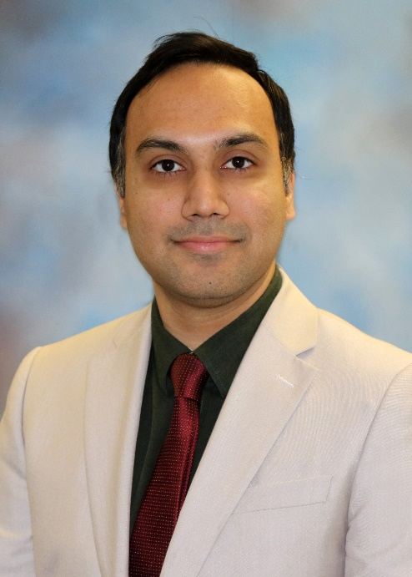  Furqan B. Irfan, MBBS (MD), PhD irfanfur@msu.edu  (517) 353-7785  Primary Site: EL& DMC  Office Hours: Request meeting via email contact. | Dr Furqan B. Irfan has MBBS (MD), PhD, MBA-background, and is an Associate Professor, Department of Neurology, and Director of Research Development, College of Osteopathic Medicine, Michigan State University (MSU COM). He has broad-ranging experience in teaching, research, global health and innovation.  At MSU COM, he is the course director and teaches Epidemiology, Biostatistics, and the Evidence-based Medicine course. His research overlaps epidemiology, public and global health, health technology, and data science (machine learning/artificial intelligence). He has over 30 peer-reviewed publications and over two million dollars in active grant funding.  Dr Irfan has served as an Advisory Board member at Health Practice, Silicon Valley Innovation Center, Infineon Technologies AG. Infineon Technologies AG, is one of the largest semi-conductors (microelectronics and sensors) manufacturers worldwide with an annual revenue of $10 (€8.6) billion in 2020. He also consults for Manhattan Strategy Group, Washington DC.

Contributing Faculty
Name | Email | Phone | Location
Furqan B. Irfan, MBBS (MD), PhD | irfanfur@msu.edu | (517) 353-7785 | EL, DMC
Carolina Restini, PhD | restinic@msu.edu | (517) 353-7145 | DMC, MUC

Course Coordinator (CC)
Name | Email | Phone | Location
Rusti Sidel | smithru2@msu.edu | 517-353-4926 | EL

Who to Contact with Questions
Question, Need, or Topic | Contact Person
Course - Logistics & Details | Contact CC for rooms, groups, materials, links, schedule, etc.
Course - Overall | Contact Course Directors (in bold above).
Course - Specific Content | Contact Contributing Faculty for the content (see schedule).
Absences | Contact Course Directors (in bold above).
Behavior | Submit exemplary or concerning behavior to the CGPI.
Enrollment | Inquire with MSUCOM Registrar.
Personal/Wellness Needs | Inquire with Wellness & Counseling.
Report kudos or suggestions related to inclusion in the curriculum | Submit a DO Better form. https://tinyurl.com/DO-Better-Form
Study Skills or Progression | Inquire with Academic & Career Advising.
Technical Support | Inquire with MSU IT Service Desk. Indicate COM affiliation.

Course Information

Course Description & Overview
Biomedical Research is a 2-3 credit hour course that provides students with biomedical research experience. Directed research enables medical students to test and compare different theories and approaches. It will allow medical students to explore different methods in order to determine better modalities for patient care and therapy. Students are enrolled in 3 credits (8-10 hours research per week for a semester) or 2 credits (4-6 hours research per week for a semester).

Course Objectives
The American Osteopathic Association has identified core competencies essential for future practice as an osteopathic physician. These are embedded throughout our programmatic and course objectives. By the end of this course, learners should be able to:

- Provide biomedical research experience
- Basic Science, translational, clinical, bioinformatics, epidemiology or public health research may be pursued
- Medical research topic is arranged with a basic scientist or clinician researcher, Research Mentor

Textbooks and Resources
Most MSUCOM courses make use of D2L as a course website to share materials, Google Calendar to share course schedules, Zoom to host online meetings, and iClicker to facilitate audience polling. Visit https://bit.ly/msucomtech for reminders on how to access and use these resources. Other course-specific resources include:

Status | Resource
Required | No Required Text
Optional | No Optional Text

Grading Schema
Course scores will be determined using the following formula:
(Combined Individual Activity or Assessment Points) / (Total Points Possible) * 100%
= Final Percent Score

Course grades will then be assigned based on those course scores as follows:
- P or Pass - Satisfactory performance has been achieved, and credit will be granted if a student’s final percent score is 70% or higher. To obtain a “P” grade for this course, a student must have completed the elective, and submitted a satisfactory student research report and student evaluation by the Research Mentor.
- N or No Grade - Satisfactory performance has not been achieved, and credit will not be granted if a student’s final percent score is below 70%. A student who does not complete the elective and/or fails to submit a satisfactory student research report and student evaluation by the Research Mentor will receive an “N” grade.

Remediation is not offered for this course.

Grading Requirements
The MSUCOM D.O. degree program incorporates both horizontal and vertical curriculum integration, meaning course activities and assessments require ongoing development and integration of knowledge and skills acquired in previous courses. Required components include:

Required Component | Projected Points | Material to be Covered
Student must provide a report on the research project at the end of the semester by email to: COM.research@msu.edu |  | Provide a narrative report of 2-3 paragraphs indicating what you did in qualitative and quantitative terms, e.g., “I examined 250 charts of previous patients that had condition XX and recorded how many of them had a high score on Y, but exhibited a low score on Z, etc.” Indicate the results and relevance of these findings to the hypothesis that the Investigator is addressing.
Research Mentor must provide a Student Evaluation at the end of the semester by email to: |  | Did the student actively participate in the research project you assigned him/her? Did they carry out the research as you expected? Did they put in the hours they had agreed to?  Were you satisfied with the student?  Based on this experience, are you willing to have other medical students participate in short-term projects with you?

Policies & Resources

Academic Support Resources at MSUCOM
Students are encouraged to connect with Academic and Career Advising (ACA) to access academic, board, and career advising across the 4-year D.O. curriculum. As a way to acclimate to the MSUCOM curriculum, you may access ACA’s On Target website for semester roadmaps, tools needed to be successful in the curriculum, and targeted resources for different learning situations. Each semester’s roadmap contains course expectations, tips, potential challenges, notes on longitudinal content and skills integration, and study guides.

College or University Policies with Which Enrolled Students Must Be Familiar
Policy | Location
Artificial Intelligence (AI) Use | Student Handbook - AI Policy
Common Ground Professionalism Initiative | MSUCOM CGPI Site
Computer-Based Testing | Student Handbook - CBT Policy
Disability & Reasonable Accommodation | Student Handbook - Diversity and Inclusion
iClicker | Student Handbook - Information Technology Resources
Medical Students Rights and Responsibilities | Office of Spartan Experiences Site
MSUCOM Academic Code of Professional Ethics | Student Handbook - Academic Code of Professional Ethics
Osteopathic Clinical Training & Student Safety | Student Handbook - Osteopathic Clinical Training & Student Safety
Preclerkship Attendance & Absences | Student Handbook - Attendance & Absences
Pregnancy and Pregnancy-Related Conditions | Pregnancy and Parenting Information | Office for Civil Rights and Title IX
Relationship Violence & Sexual Misconduct & Title IX | Office for Civil Rights & Title IX Education & Compliance Site
Religious Observance Policy | Office of the Registrar Site
Remediation | Student Handbook - Remediation
Student Handbook | Student Handbook

Student Feedback
MSUCOM values student feedback, using this to model practice-based learning and improvement, and to promote continuous quality improvement of learning experiences.

Route | Description
Informal | We invite you to respectfully provide constructive suggestions to Course Directors, Contributing Faculty, or Curriculum Assistants at any time.
Formal | MSUCOM will deploy brief surveys through Medtrics to gain feedback on the Course, Course Directors and Contributing Faculty.  Additionally, MSU sends an optional Student Perceptions of Learning Survey (SPLS) to enrolled students at the conclusion of each course to gain feedback on the course and Course Directors.

Course Schedule and Changes to Schedule or Requirements
Due to external circumstances (e.g., weather/maintenance closures, clinical obligations, student cohort needs, etc.), course requirements published in the course syllabus and/or course schedule may be subject to change. Timely communication regarding changes will be provided to enrolled students via the course D2L site, Google Calendar, and/or MSU email. Contact course coordinators with questions. Any changes made will be considerate of the MSU Code of Teaching Responsibility and the Medical Students Rights and Responsibilities.

Addendum: Course Schedule
Updated 11.06.2025
Date | Time | Topic/Title | Theme | Faculty | Event Type | Venue  (Origin*) | Notes
1/5/26 – 4/26/26 | As agreed by student and research advisor | Experiential research |  | Furqan Irfan | Flexible Live | (EL, DMC, MUC) | NA

